Lost & Found Therapy
HOME
Therapy that feels warm, human and at-home – for when things feel difficult.
Your safe, comfortable, judgement-free corner for healing, support and growth – as you do life and adulting.
To slow down, understand yourself a little better, make sense of what you’re carrying, and come a little closer to yourself.
Button: Book a session Button: About me
Online therapy for adults
A little reminder (see picture below): You can come as you are. You don’t need the right words, a perfect explanation, or everything figured out before you begin.
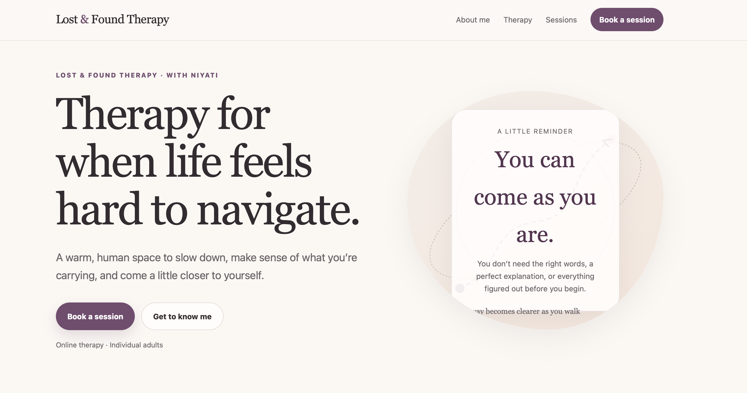

IF YOU’VE LANDED HERE
Maybe things haven’t felt quite right.
Maybe life has felt heavier lately. Maybe your mind won’t switch off. Maybe you’ve been holding everything together for so long that you’re not quite sure what you need anymore.
Or maybe nothing feels particularly “wrong”, and you just feel stuck, disconnected, overwhelmed, or unlike yourself. Maybe relationships feel confusing, overwhelming, or emotionally draining.
There’s no “right way” to show up for therapy, or a “right time” to begin. You don’t need to know where to start or exactly what to say. You don’t need to wait until you’re at rock bottom or until things feel “bad enough” to reach out.
Whether you feel sad, confused, anxious, numb, stressed, hopeful, exhausted, angry, lost, or uncertain – all of you is welcome here.
You can simply come as you are – with all the things you understand, and all the things you’re still trying to make sense of. Therapy can begin with something as simple as, “I’m not really sure what’s going on, but I know I don’t want to keep feeling this way.”
Therapy is about understanding yourself better, processing what you’ve been carrying, and feeling a little less alone through it all.
And I’m here to walk with you as you gently explore your experiences, thoughts, and emotions. We can talk about what has been happening, what has been hard, and what you would like to be different. We’ll take it one step at a time, at a pace that feels manageable for you.
You start where you are, we can figure out the rest together.
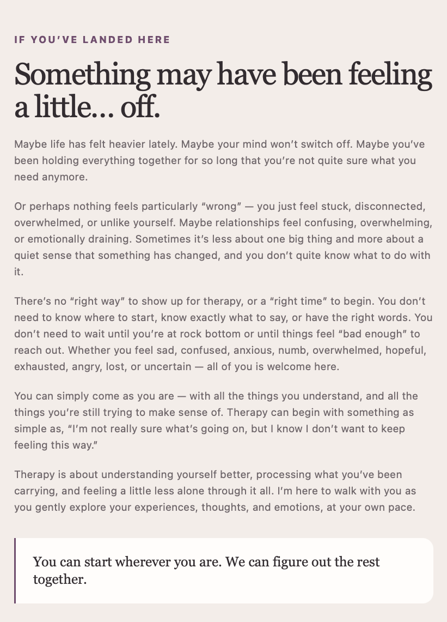

A LITTLE ABOUT ME
Human first, therapist later.
Hi, I’m Niyati – a Counselling Psychologist & Psychotherapist with a Master’s degree in Clinical Psychology, supporting adults in their journey of self-discovery, healing, and growth.
MSc in Clinical Psychology Counselling Psychologist and Psychotherapist
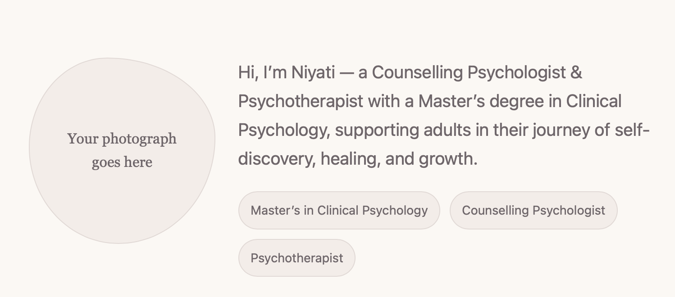
I’ve always been someone who listens deeply, feels fully, and stays curious about people’s stories. I find myself especially drawn to the little things beneath the surface: the patterns we repeat, the things we protect ourselves from, and the ways our life experiences shape the way we relate to ourselves and others. So many of our struggles come from patterns we were never taught to notice – how we think, feel, relate, react, attach, seek, cope, survive, and feel safe.
I believe you are the expert of your own inner world. You’ve lived your story, felt your emotions, and carried your experiences. Yet sometimes, we all need support – someone to sit with us, listen without judgment, help us make sense of whatever feels heavy, and find our way back to ourselves.
That’s what therapy is for, and what I hope to offer you – a warm, supportive, collaborative, safe, and comfortable space where you can show up exactly as you are – with someone walking with you, one step at a time. My hope is that therapy with me feels less like being “fixed” and more like having a safe place to pause, understand yourself a little better, and improve your relationships with yourself and others.
The goal isn’t to feel happy all the time, but to feel more aware, resilient and emotionally equipped to navigate the highs and lows of life.
I believe therapy works best as a partnership, not from a place of “expert and client,” but two humans collaboratively exploring your story, to help you rediscover yourself.
In therapy, we might look at patterns that keep showing up, things you find hard to talk about, or ways you’ve learnt to cope. Therapy won’t always be easy, and I won’t have all the answers. My hope is that we can be curious together about what’s going on and what might help.
I don’t think therapy is about someone having all the answers. It’s about having a place where you can be seen, heard, supported, and slowly create a life that feels more true to YOU.
My approach is relational and trauma-informed. I aim to create a space that is inclusive, affirming, and respectful of different identities, relationships, cultures, and lived experiences. I try to make sessions a space where you can speak openly, take up space, and feel respected.
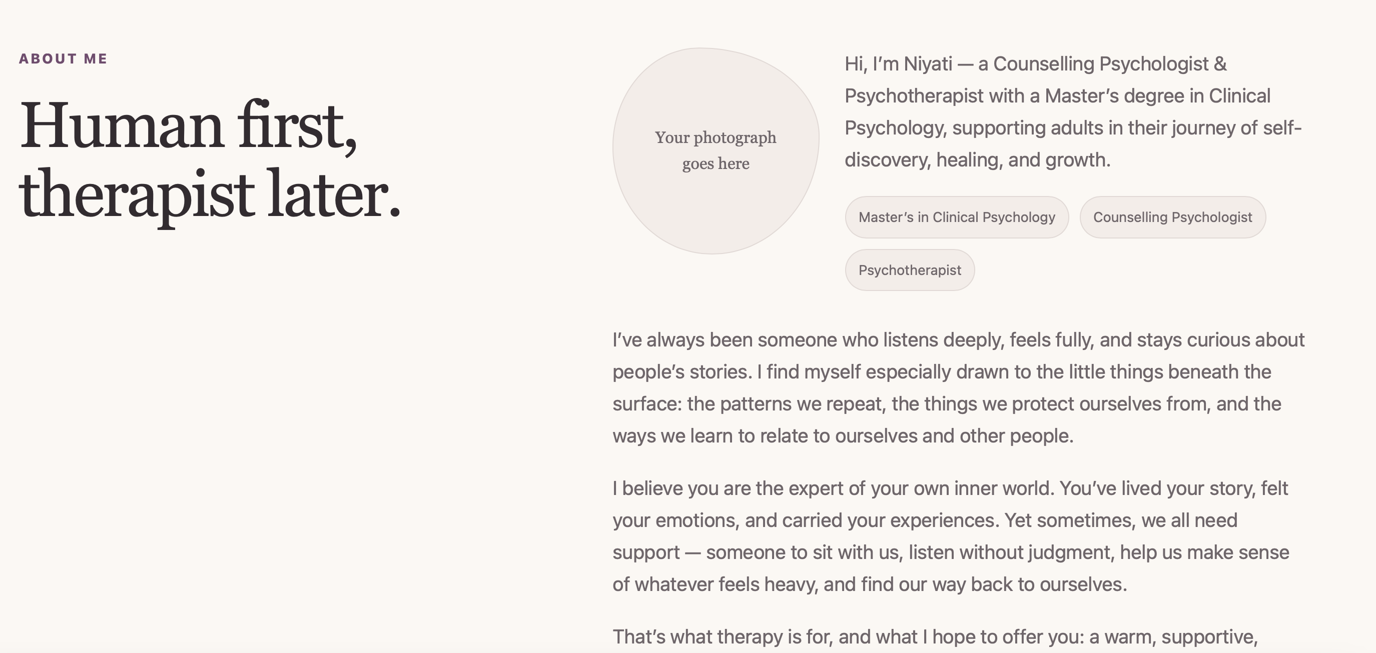

WHAT THERAPY CAN BE LIKE
What can we work on in therapy?
Sometimes, life can feel a little like being somewhere unfamiliar without a clear map. You may know that you’re tired, overwhelmed, stuck, or unhappy; but not quite understand how you got here, why certain things keep happening, why we get stuck in the same situations, or which way to go next.
Therapy can be a space to unfold the map together. We can look at the roads you’ve travelled before, the paths you learned to take early on, the places where you tend to get stuck, and the ways you’ve learned to protect yourself along the way.
Sometimes we discover that a path that once helped you feel safe no longer fits where you are now. Sometimes we realise there are roads you’ve never allowed yourself to explore. And sometimes, before deciding where to go, we simply understand where we are.
I’m not there to decide your destination for you. I’m there to help you read the map, notice what may have been missed, stay alongside you when the terrain feels difficult, and make room for new turns and pathways.
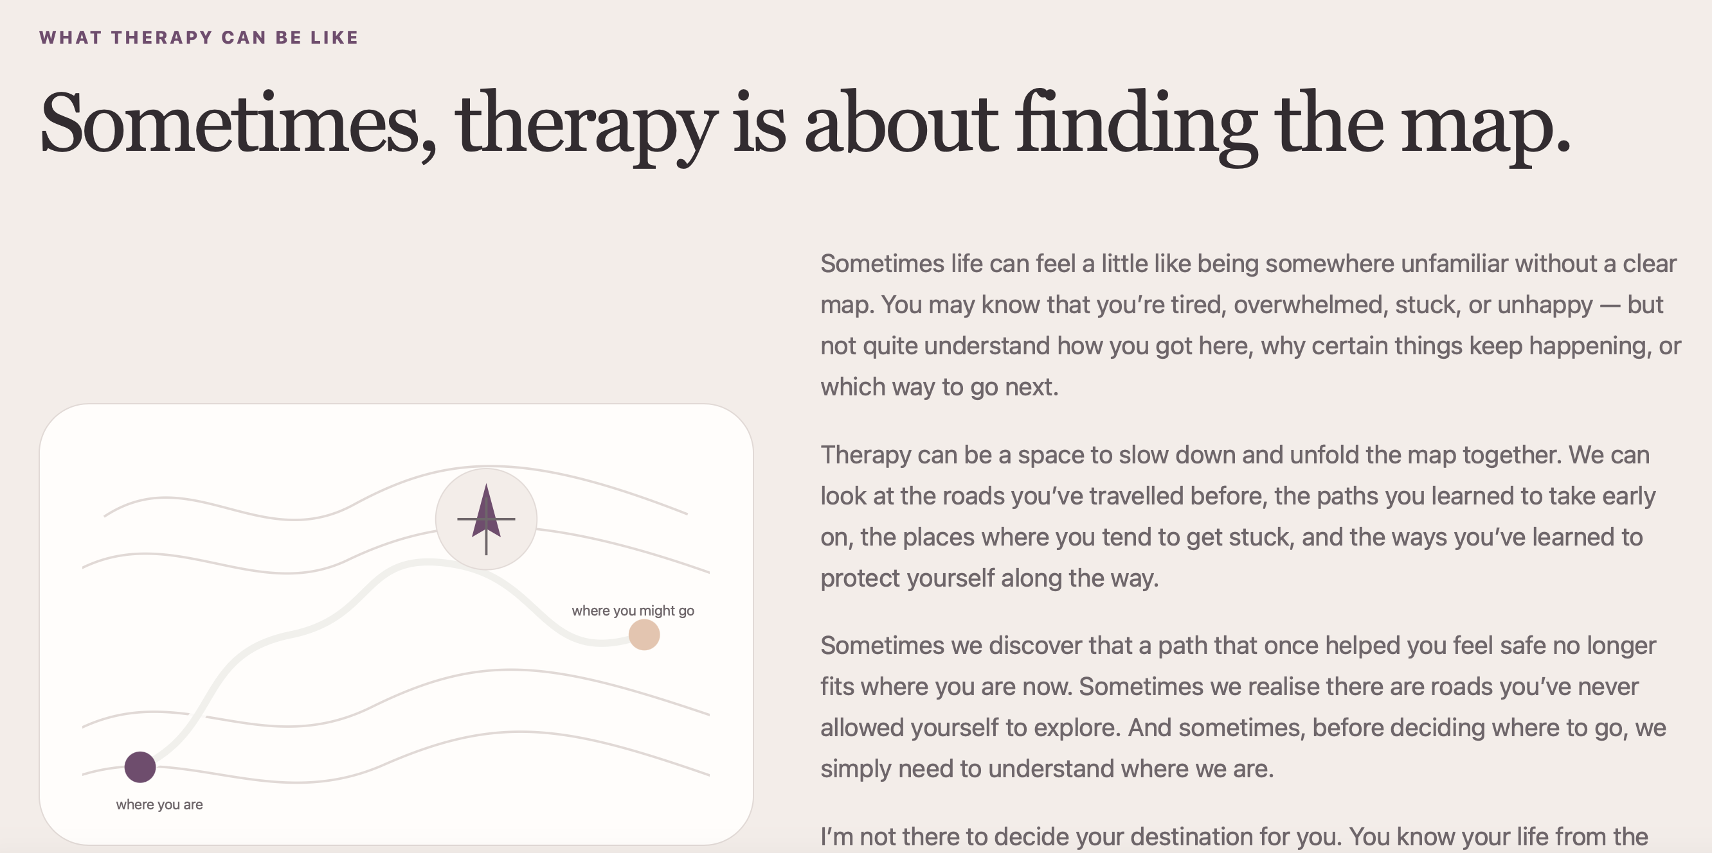

WHAT WE CAN WORK ON
There’s no neat checklist for being human.
Whatever you’re carrying, you can bring it here.
- Stress and burnout
- Anxiety, OCD and overthinking
- Fears, doubts and chronic worry
- Self-doubt and self-confidence
- Emotional dysregulation
- Grief and loss
- Panic and restlessness
- Loneliness and disconnection
- Anger and irritability
- Self-criticism, shame and guilt
- Lifestyle and sleep issues
- Unhelpful coping, patterns and cycles
- Body image and acceptance
- Identity confusion and existential dread
- Family discord and dynamics
- Attachment and relationship conflicts
- Life transitions, change and adjustment
- Work-life balance and distress
- Demotivation and procrastination
- Traumatic experiences
- Low mood and emotional exhaustion
- Interpersonal relationships
This list isn’t exhaustive. If something is bothering you or affecting your everyday life, we can always talk about it even if you’re not sure what to call it.
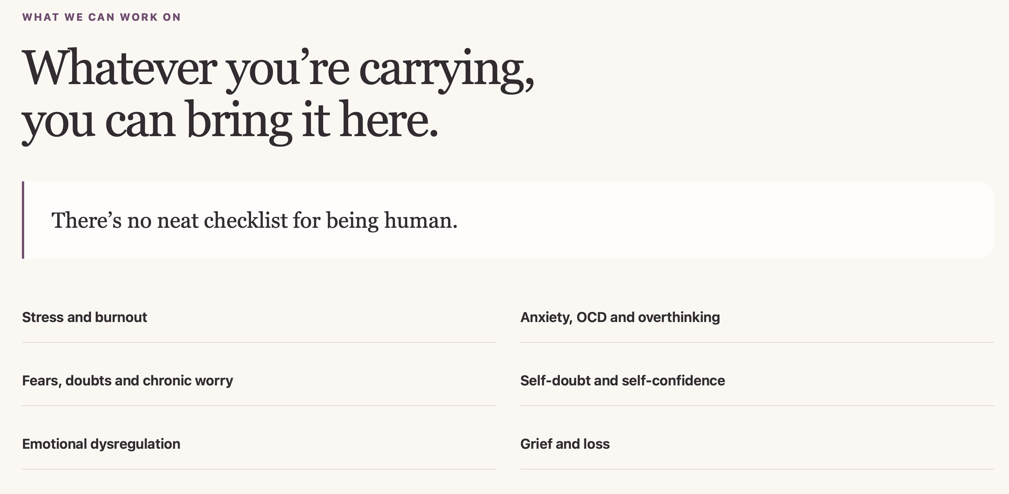

ABOUT THE SESSIONS
Duration: 50-60 minutes per session
Fees: ₹1,750 per session for clients based in India; ₹4,750 per session for clients based outside India
Limited sliding-scale spaces are available for students and for those experiencing financial constraints. If this is a barrier, you’re welcome to mention this when you reach out.
Mode: Sessions are only online via Google Meet or Zoom.
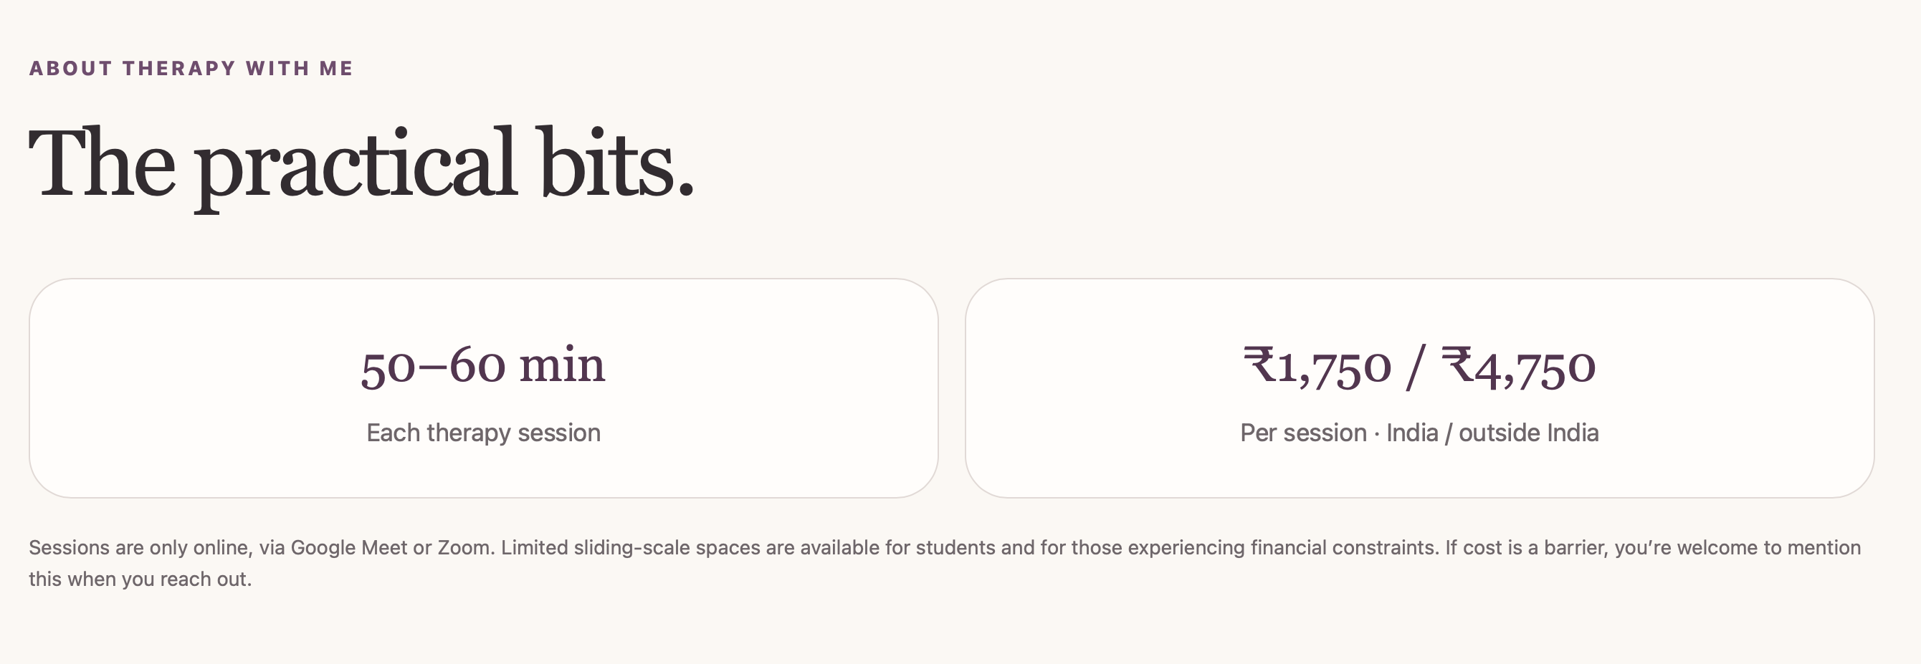

BEFORE WE BEGIN
A few things you might be wondering.

(drop down format) “I don’t know what to talk about. Is that okay?”
Absolutely. You don’t need a neatly organised story, a clear diagnosis, or a list of things you want to work on before your first session. We can start with whatever feels easiest to say, even “I don’t really know why I’m here” or “I just know that something doesn’t feel right.” Part of our work together can be figuring out what is important to you and where we might begin.

“Do I need to have a diagnosis?”
No. You don’t need a diagnosis or a particular label to seek therapy. People come to therapy for many different reasons: something may feel difficult or confusing, you may feel stuck in a pattern, a relationship may be hurting, or you may simply want a deeper understanding of yourself. We can start with what’s happening for you without needing to fit your experience into a box first.

“What if I’m not sure therapy is for me?”
That’s completely okay. Getting in touch doesn’t mean you have to commit to long-term therapy. The first conversation can simply be a chance to meet, understand what you’re looking for, and get a sense of whether working together feels comfortable and useful. It’s okay to take your time with that decision.

“Will you tell me what I should do?”
Therapy is collaborative rather than advice-giving. I won’t pretend to know your life better than you do or tell you what choices you should make. Instead, we’ll explore what is happening, understand the patterns and needs underneath it, and think together about what feels possible. You remain the expert on your own life and the decisions that belong to you.

“How often will we meet?”
We can talk about what frequency makes sense for you based on what you’re looking for and what feels manageable. Many people begin with regular (weekly) sessions so there is enough continuity to build a therapeutic relationship and make space for the work. We can revisit what is working for you as therapy progresses.

“Are sessions only online?”
Yes. Sessions are conducted online through Google Meet or Zoom. It is important to join from somewhere you can speak privately and feel comfortable and undisturbed.

“What if I’m having a really difficult day?”
You are welcome to bring difficult days here. Therapy can be a space to talk about intense emotions, difficult experiences, and moments when things feel especially hard. At the same time, online therapy is NOT an emergency or crisis service. If you are in immediate danger, feel unable to keep yourself safe, or need urgent support, please contact your local emergency or crisis service or go to the nearest emergency department rather than waiting for a therapy appointment.
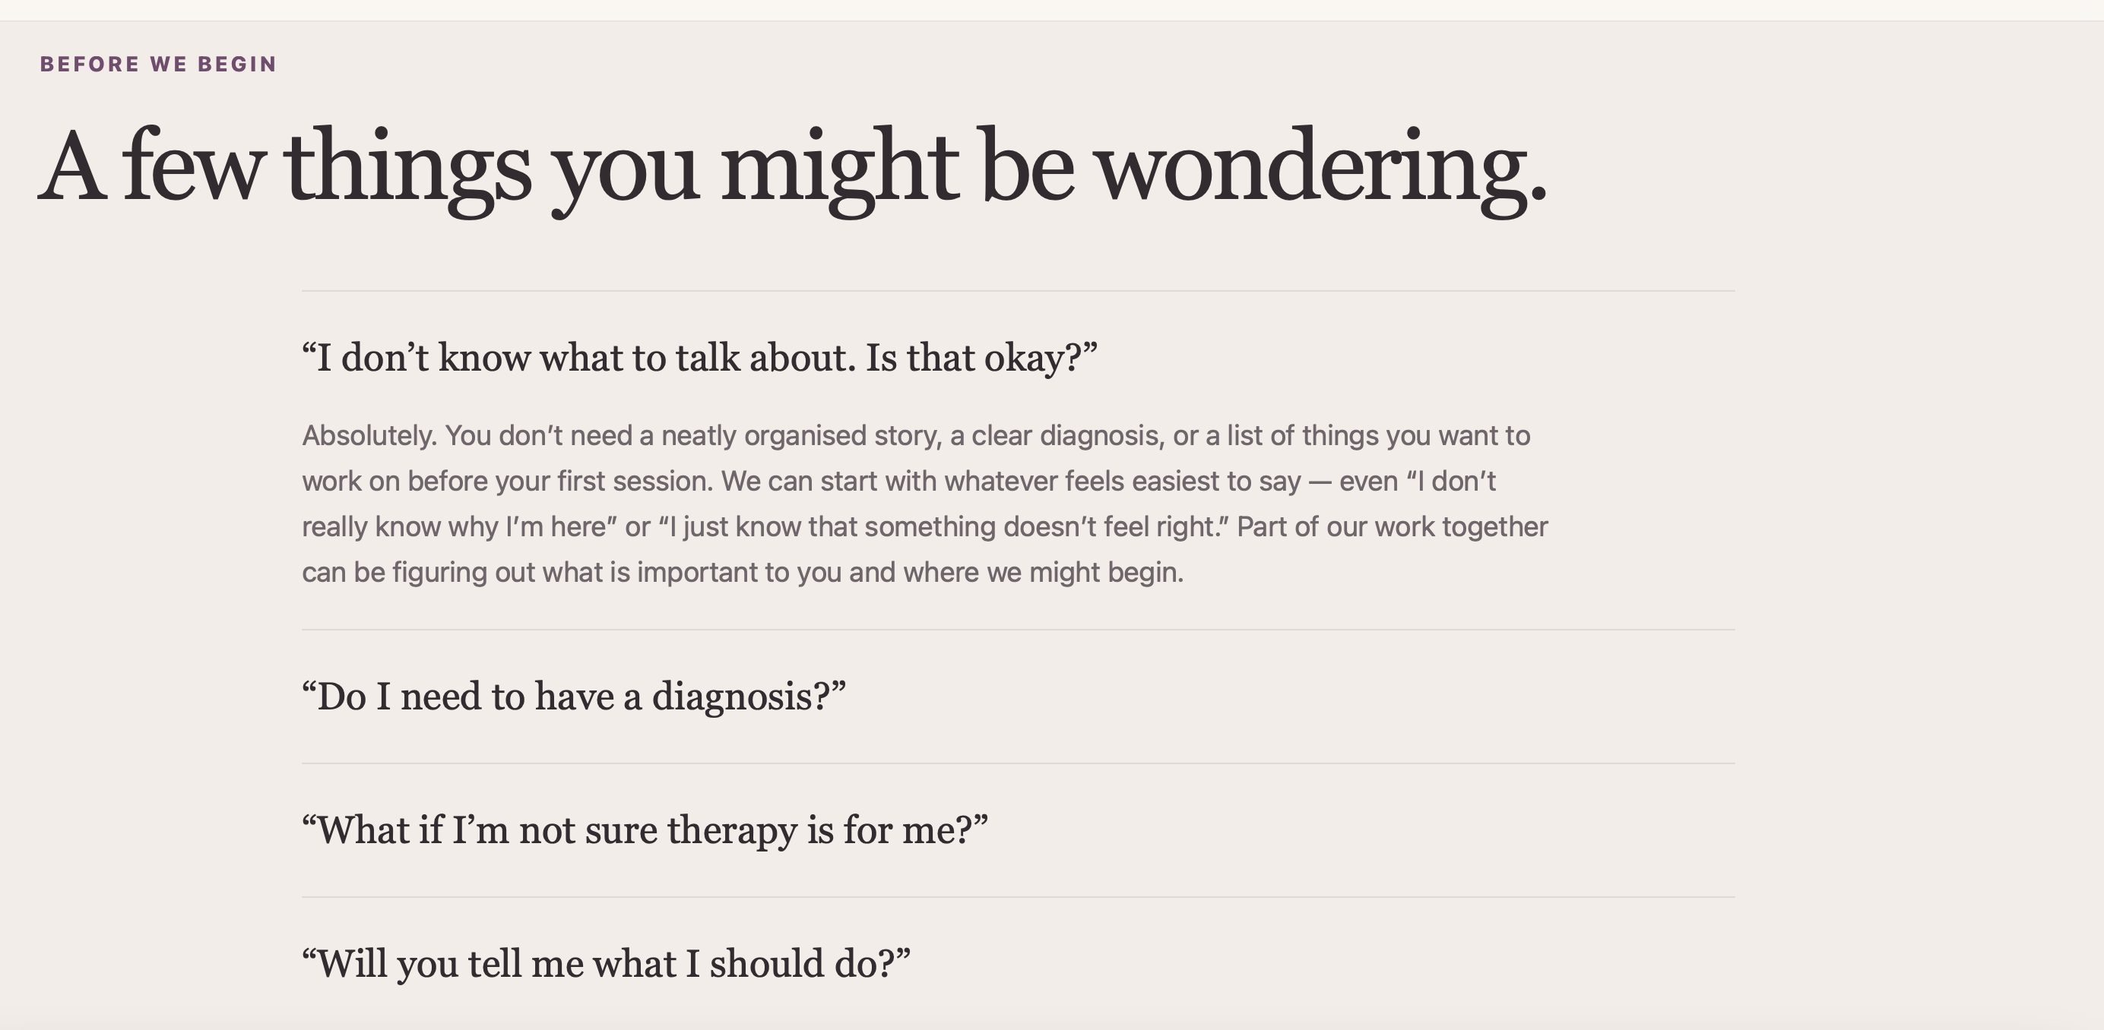
GETTING STARTED
If you’d like to begin, here are two ways to reach me.

Book directly
If you already know you’d like to begin, you can choose a convenient slot.
Button: Book a session (Redirect to Topmate)

Reach out first
If you’d rather share a little about yourself or ask a question before booking, fill out the short form and I’ll reach out to you to schedule a 15-minute consultation call.
Button: Fill the enquiry form (Redirect to google form)
And if you’re still unsure, that’s okay. You don’t have to make a big decision today. You can simply start a conversation.
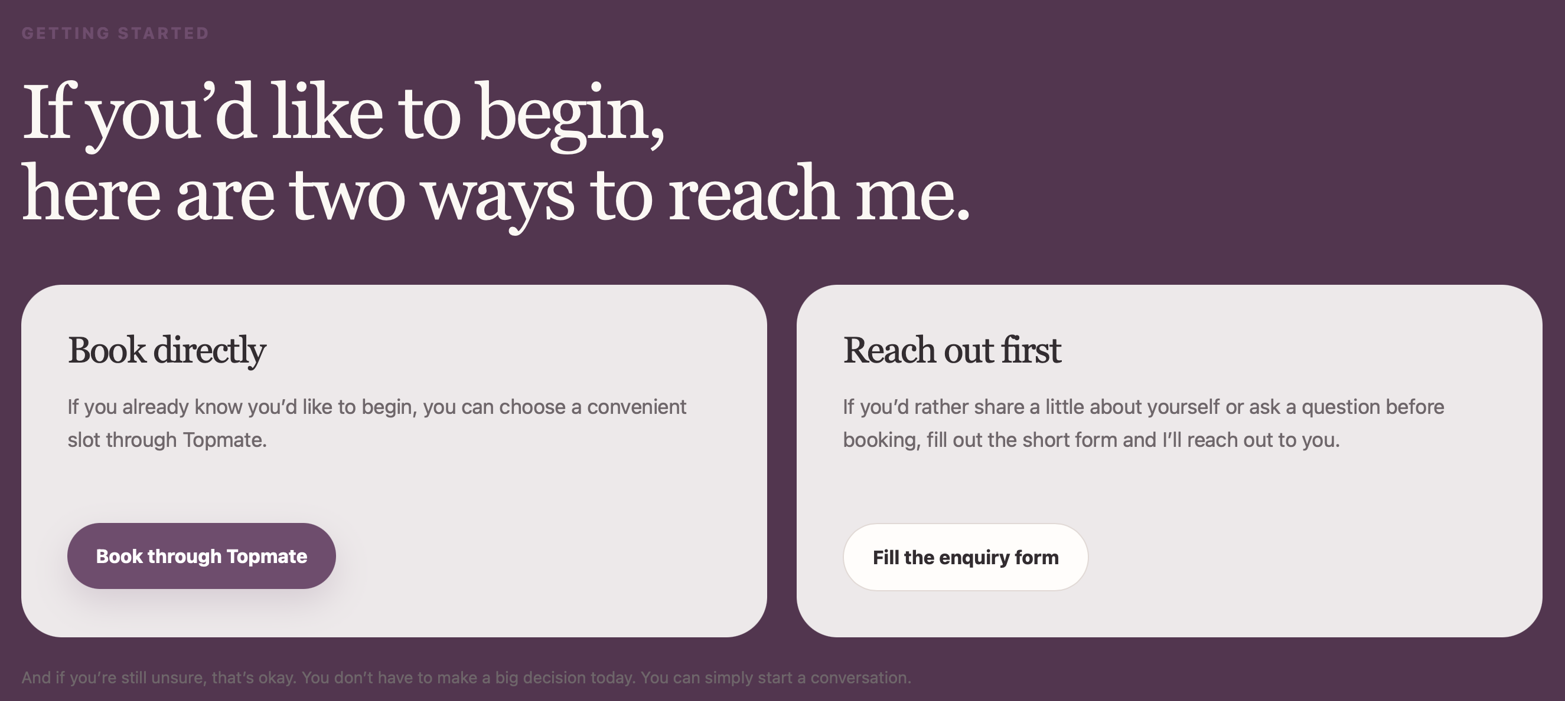
“You can’t stop the waves, but you can learn to surf”

MORE ABOUT ME
WhatsApp (button) Instagram (button) LinkedIn (button)

Footer:
Therapy with Niyati Bagla · Counselling Psychologist & Psychotherapist
This website is for information and appointment enquiries; it is not a substitute for emergency care.

